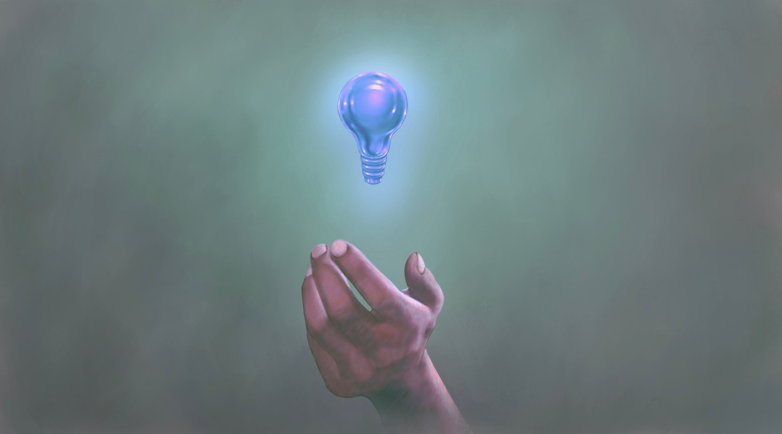

Art appreciation has really been thought provoking and it really widened my horizons regarding the vast space that is called art. I learned a lot of things more on the abstract aspect of art which allows me to, in turn, appreciate the finer, intricate details that go into the craft.